EDDMapS Smartphone App Instructions

- Download this app from Playstore or Apple:

- The first image to the right is the home screen when the app is opened

- Choose New Sighting to report – then tap Select a Subject (second image to right) to go to the invasive species list (third image to right).
  - Use the magnifying glass in the upper right to search for a particular species; enter a few letters and the choices will narrow.
  - You can toggle between alphabetizing by Latin name or by common name by hitting ‘a>z’ on the gray bar at the top of the screen.
  - Click the species name and the name is filled in on the report form.

- Report form
  - Species is automatically entered once you have selected it. You can add more invasive species for this site if you wish.
  - Images. Click the dashed box under the word ‘Images’ and you will be asked if you want to take a picture or choose a picture already on your phone. Choose one or the other. If you take a picture, it will show you the picture and you confirm it (click on check mark) or delete it (click on ‘x’) and try again. Once you confirm it, the photo is automatically added to your report and a thumbnail shows. You can attach multiple photos. Be sure to include photos that clearly show the whole plant and any close ups that are needed to identify the species.
  - Observation Date is automatically entered
  - Hide exact location? If this is a location that needs to stay private for some reason, click this box.

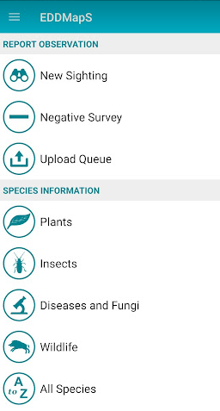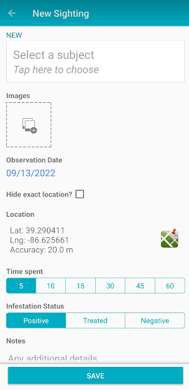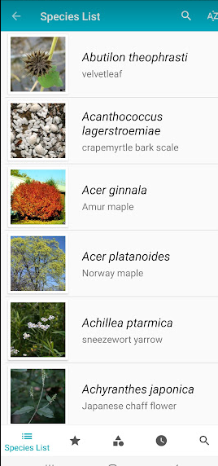

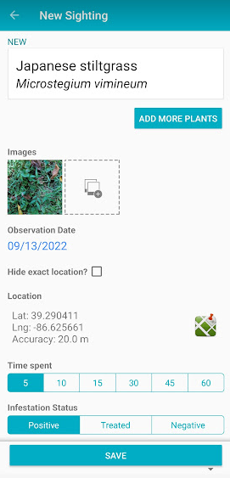

  - Location. Lat and long are automatically entered based on your current location. Click the map icon to go to a map of current location. At this point you can simply accept the marker where it is and click ‘Done’, or move the marker, or choose the Polygon tab and actually draw a line or polygon to show the infestation, and then click ‘Done’.

  - Time Spent in Minutes. Useful for groups who want to track volunteer or staff efforts, otherwise no need to answer.
  - Infestation Status. Positive for new reports, Treated for those that were controlled, Negative for cases where a species was searched for and not found.
  - Infestation.
    - Habitat – there are several dropdown options, choose the one that best fits the site.
    - Area - Enter the estimated size of the infestation and choose Acres or Square Feet.
    - Density. Choose <5%, 5-25%, 25-50%, or >50% cover based on your best judgement.
  - Notes. Add any additional helpful information, like landmarks or whether you controlled the infestation.
  - Save. Click ‘save’ and the report will go to the ‘Upload Queue’. It will stay there until you go to the Upload Queue and click Upload in the upper right corner. This allows you to wait until you have good connectivity to upload reports.

- Negative Survey – you can report areas you have surveyed for a particular invasive species and NOT found it. This is not commonly used.

- Upload Queue – this is where saved reports are. Select it to see the reports in the queue. Reports can still be edited at this point. When ready, click the upload arrow in the upper right of the screen and the report will be submitted.

